FERPA Authorizations at Pearl River Community College (SSB Banner)

FERPA and FERPA authorizations are presented to students and parents during our orientation (ROAR) sessions throughout the summer.
Notes:
*We were given the initial code from Houston Baptist University, with permission to share.
*We built this within Banner 8 SSB environment.
- Webtailor Role = “All Web Users”
*We used Remote technical resources within Ellucian for development:
- 1 custom SSB page (Authorization form)
- 1 custom trigger (“submit button” on Authorization form)
- 2 custom packages (FERPA authorizations inserted into SPACMNT)

Steps to complete FERPA Authorization (student):
- Log into Riverguide (Ellucian sharepoint portal)

- Click on Wildcat Web (Banner Self Service)

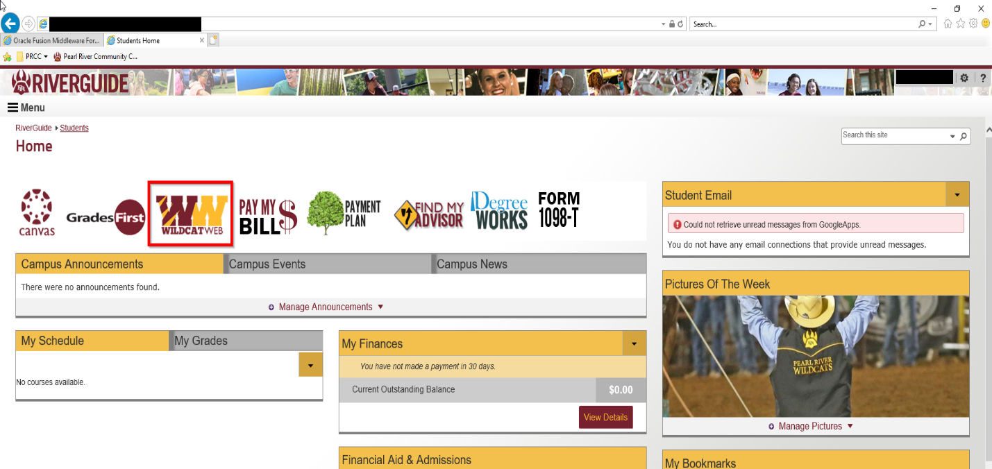

- Student is auto-directed to the “student” tab within Wildcat Web (Banner Self Service). They can also find the “FERPA” under the “personal” tab.
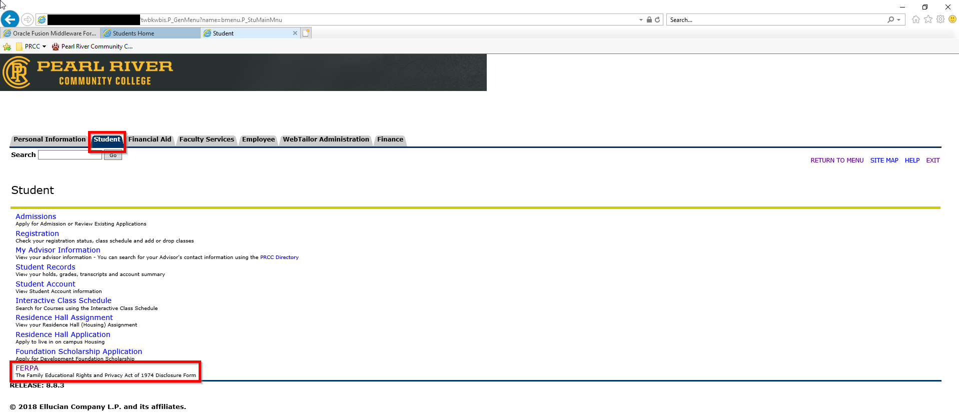
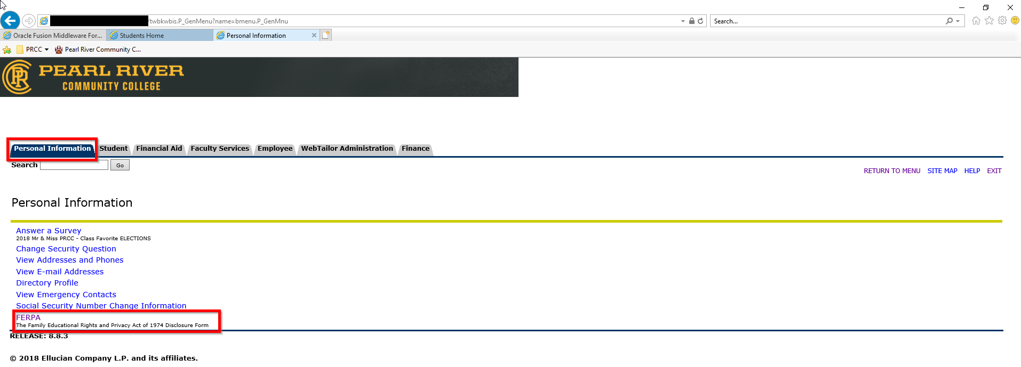
- Student clicks on “FERPA” menu option, and is presented with our FERPA Authorization Form.
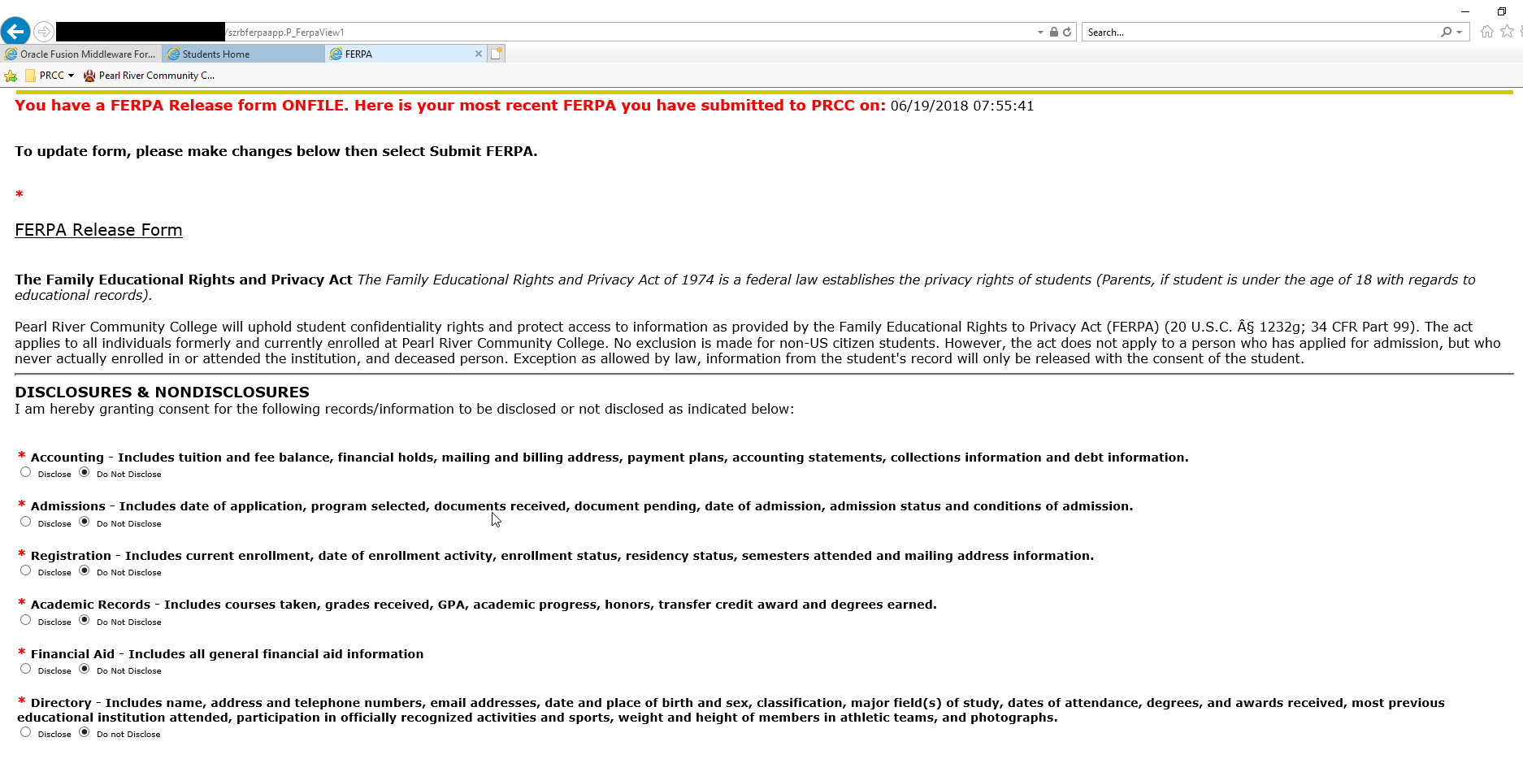
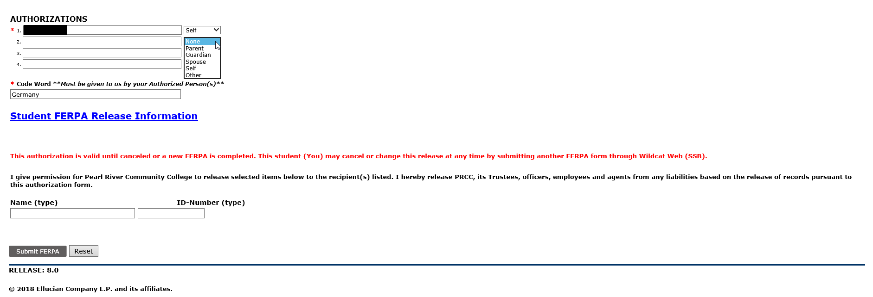
- After completing REQUIRED fields (denoted by red *), typing in Name and ID number (e-signature)…they click “SUBMIT” and the authorizations are instered into INB Banner.

Administrative View of FERPA Authorization
- For ANY administrative person at Pearl River they can access the FERPA authorization on SPACMNT.
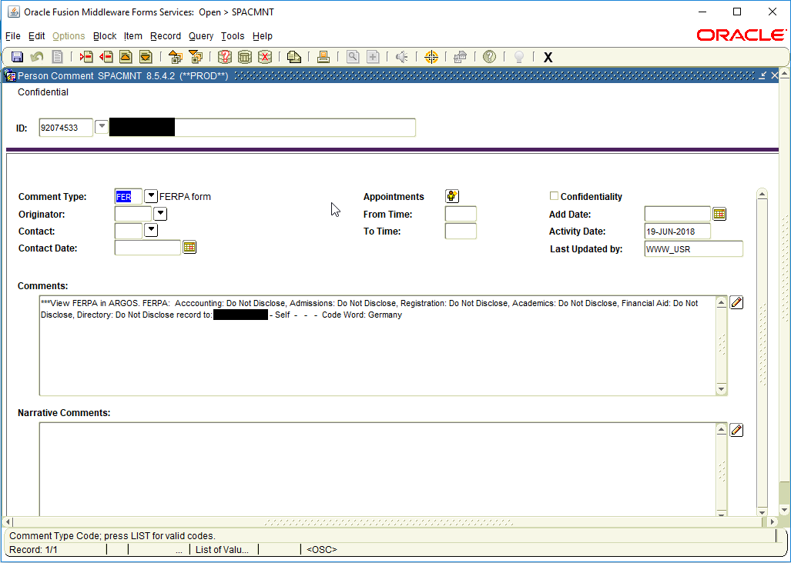
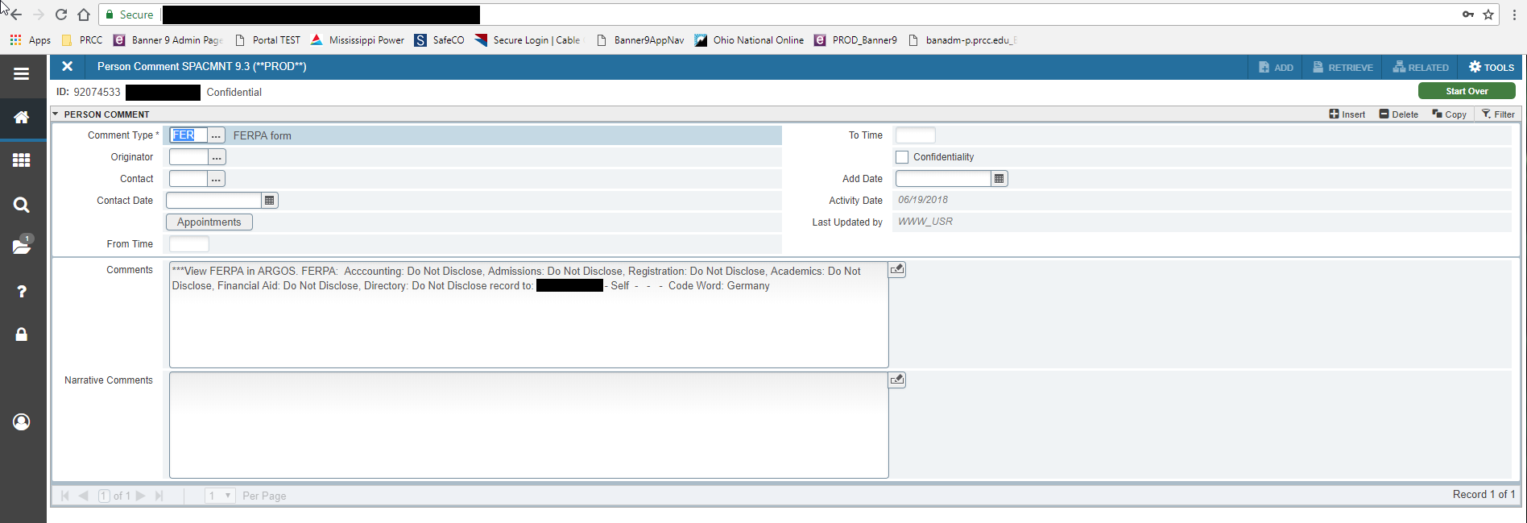

Technical Parts of the Application

Below you will find some technical references for how we built the FERPA Authorizations within Banner Self Service.

Custom Self Service Page: szrbferpaapp.P_FerpaView1

<!DOCTYPE HTML PUBLIC "-//W3C//DTD HTML 4.01 Transitional//EN" "http://www.w3.org/TR/html4/loose.dtd">
<HTML lang="en">
<HEAD>
<META http-equiv="Content-Type" content="text/html; charset=UTF-8">
<META HTTP-EQUIV="Pragma" NAME="Cache-Control" CONTENT="no-cache">
<META HTTP-EQUIV="Cache-Control" NAME="Cache-Control" CONTENT="no-cache">
<LINK REL="stylesheet" HREF="/css/web_defaultapp.css" TYPE="text/css">
<LINK REL="stylesheet" HREF="/css/web_defaultprint.css" TYPE="text/css" media="print">
<TITLE>FERPA</TITLE>
<META HTTP-EQUIV="Content-Script-Type" NAME="Default_Script_Language" CONTENT="text/javascript">
<SCRIPT LANGUAGE="JavaScript" TYPE="text/javascript">
<!-- Hide JavaScript from older browsers
window.onunload = function() {submitcount=0;}
var submitcount=0;
function checkSubmit() {
if (submitcount == 0)
{
submitcount++;
return true;
}
else
{
alert("Your changes have already been submitted.");
return false;
}
}
// End script hiding -->
</SCRIPT>
<SCRIPT LANGUAGE="JavaScript" TYPE="text/javascript">
<!-- Hide JavaScript from older browsers
// Function to open a window
function windowOpen(window_url) {
helpWin = window.open(window_url,'','toolbar=yes,status=no,scrollbars=yes,menubar=yes,resizable=yes,directories=no,location=no,width=350,height=400');
if (document.images) {
if (helpWin) helpWin.focus()
}
}
// End script hiding -->
</SCRIPT>
</HEAD>
<BODY>
<DIV class="headerwrapperdiv">
<DIV class="pageheaderdiv1">
<A HREF="#main_content" onMouseover="window.status='Go to Main Content'; return true" onMouseout="window.status=''; return true" OnFocus="window.status='Go to Main Content'; return true" onBlur="window.status=''; return true" class="skiplinks">Go to Main Content</A>
<H1><HTML><FONT COLOR=660000>PEARL RIVER COMMUNITY COLLEGE</FONT></HTML></H1></DIV><DIV class="headerlinksdiv">
<SPAN class="pageheaderlinks2">
<MAP NAME="Module_Navigation_Links_H" title="Module Navigation Links">
<p>
<A HREF="#skip_Module_Navigation_Links_H" onMouseover="window.status='Skip Module Navigation Links'; return true" onMouseout="window.status=''; return true" onFocus="window.status='Skip Module Navigation Links'; return true" onBlur="window.status=''; return true" class="skiplinks">Skip Module Navigation Links</A>
<TABLE CLASS="plaintable" SUMMARY="This is main table for displaying Tab Items."
WIDTH="100%" cellSpacing=0 cellPadding=0 border=0>
<TR>
<TD CLASS="pldefault">
<TABLE CLASS="plaintable" SUMMARY="This table displays Tab Items."
cellSpacing=0 cellPadding=0 border=0>
<TR>
<td class="taboff" height=22>
<A HREF="/PROD/twbkwbis.P_GenMenu?name=bmenu.P_GenMnu" onMouseover="window.status='Personal Information'; return true" onMouseout="window.status=''; return true" onFocus="window.status='Personal Information'; return true" onBlur="window.status=''; return true" >Personal Information</A>
</TD>
<TD class="bgtaboff" height=22 vAlign="top" align="right">
<IMG SRC="/wtlgifs/web_tab_corner_right.gif" ALT="Tab Corner Right" CLASS="headerImg" TITLE="Tab Corner Right" NAME="web_tab_corner_right" HSPACE=0 VSPACE=0 BORDER=0 HEIGHT=20 WIDTH=8>
</TD>
<td class="tabon" height=22>
<A HREF="/PROD/twbkwbis.P_GenMenu?name=bmenu.P_StuMainMnu" onMouseover="window.status='Student'; return true" onMouseout="window.status=''; return true" onFocus="window.status='Student'; return true" onBlur="window.status=''; return true" >Student</A>
</TD>
<TD class="bgtabon" height=22 vAlign="top" align="right">
<IMG SRC="/wtlgifs/web_tab_corner_right.gif" ALT="Tab Corner Right" CLASS="headerImg" TITLE="Tab Corner Right" NAME="web_tab_corner_right" HSPACE=0 VSPACE=0 BORDER=0 HEIGHT=20 WIDTH=8>
</TD>
<td class="taboff" height=22>
<A HREF="/PROD/twbkwbis.P_GenMenu?name=bmenu.P_FinAidMainMnu" onMouseover="window.status='Financial Aid'; return true" onMouseout="window.status=''; return true" onFocus="window.status='Financial Aid'; return true" onBlur="window.status=''; return true" >Financial Aid</A>
</TD>
<TD class="bgtaboff" height=22 vAlign="top" align="right">
<IMG SRC="/wtlgifs/web_tab_corner_right.gif" ALT="Tab Corner Right" CLASS="headerImg" TITLE="Tab Corner Right" NAME="web_tab_corner_right" HSPACE=0 VSPACE=0 BORDER=0 HEIGHT=20 WIDTH=8>
</TD>
<td class="taboff" height=22>
<A HREF="/PROD/twbkwbis.P_GenMenu?name=bmenu.P_FacMainMnu" onMouseover="window.status='Faculty Services'; return true" onMouseout="window.status=''; return true" onFocus="window.status='Faculty Services'; return true" onBlur="window.status=''; return true" >Faculty Services</A>
</TD>
<TD class="bgtaboff" height=22 vAlign="top" align="right">
<IMG SRC="/wtlgifs/web_tab_corner_right.gif" ALT="Tab Corner Right" CLASS="headerImg" TITLE="Tab Corner Right" NAME="web_tab_corner_right" HSPACE=0 VSPACE=0 BORDER=0 HEIGHT=20 WIDTH=8>
</TD>
<td class="taboff" height=22>
<A HREF="/PROD/twbkwbis.P_GenMenu?name=pmenu.P_MainMnu" onMouseover="window.status='Employee Services'; return true" onMouseout="window.status=''; return true" onFocus="window.status='Employee Services'; return true" onBlur="window.status=''; return true" >Employee</A>
</TD>
<TD class="bgtaboff" height=22 vAlign="top" align="right">
<IMG SRC="/wtlgifs/web_tab_corner_right.gif" ALT="Tab Corner Right" CLASS="headerImg" TITLE="Tab Corner Right" NAME="web_tab_corner_right" HSPACE=0 VSPACE=0 BORDER=0 HEIGHT=20 WIDTH=8>
</TD>
<td class="taboff" height=22>
<A HREF="/PROD/twbkwbis.P_GenMenu?name=bmenu.P_WebTailorMnu" onMouseover="window.status='WebTailor'; return true" onMouseout="window.status=''; return true" onFocus="window.status='WebTailor'; return true" onBlur="window.status=''; return true" >WebTailor Administration</A>
</TD>
<TD class="bgtaboff" height=22 vAlign="top" align="right">
<IMG SRC="/wtlgifs/web_tab_corner_right.gif" ALT="Tab Corner Right" CLASS="headerImg" TITLE="Tab Corner Right" NAME="web_tab_corner_right" HSPACE=0 VSPACE=0 BORDER=0 HEIGHT=20 WIDTH=8>
</TD>
<td class="taboff" height=22>
<A HREF="/PROD/twbkwbis.P_GenMenu?name=bmenu.P_FinanceMnu">Finance</A>
</TD>
<TD class="bgtaboff" height=22 vAlign="top" align="right">
<IMG SRC="/wtlgifs/web_tab_corner_right.gif" ALT="Tab Corner Right" CLASS="headerImg" TITLE="Tab Corner Right" NAME="web_tab_corner_right" HSPACE=0 VSPACE=0 BORDER=0 HEIGHT=20 WIDTH=8>
</TD>
</TR>
</TABLE>
</TD>
</TR>
<TR>
<TD class="bgtabon" width="100%" colSpan=2><IMG SRC="/wtlgifs/web_transparent.gif" ALT="Transparent Image" CLASS="headerImg" TITLE="Transparent Image" NAME="web_transparent" HSPACE=0 VSPACE=0 BORDER=0 HEIGHT=3 WIDTH=10></TD></TR></TABLE>
</MAP>
</SPAN>
<a name="skip_Module_Navigation_Links_H"></a>
</DIV>
<TABLE CLASS="plaintable" SUMMARY="This table displays Menu Items and Banner Search textbox."
WIDTH="100%">
<TR>
<TD CLASS="pldefault">
<DIV class="headerlinksdiv2">
<FORM ACTION="/PROD/twbksrch.P_ShowResults" METHOD="POST">
Search
<SPAN class="fieldlabeltextinvisible"><LABEL for=keyword_in_id><SPAN class="fieldlabeltext">Search</SPAN></LABEL></SPAN>
<INPUT TYPE="text" NAME="KEYWRD_IN" SIZE="20" MAXLENGTH="65" ID="keyword_in_id">
<INPUT TYPE="submit" VALUE="Go">
</FORM>
</div>
</TD>
<TD CLASS="pldefault"><p class="rightaligntext" /p>
<SPAN class="pageheaderlinks">
<A HREF="/PROD/twbkwbis.P_GenMenu?name=bmenu.P_StuMainMnu" class="submenulinktext2" id="ssbbackurl">RETURN TO STUDENT MENU</A>
|
<A HREF="/PROD/twbksite.P_DispSiteMap?menu_name_in=bmenu.P_MainMnu&amp;depth_in=2&amp;columns_in=3" accesskey="2" class="submenulinktext2">SITE MAP</A>
|
<A HREF="/wtlhelp/twbhhelp.htm" accesskey="H" onClick="popup = window.open('/wtlhelp/twbhhelp.htm', 'PopupPage','height=500,width=450,scrollbars=yes,resizable=yes'); return false" target="_blank" onMouseOver="window.status=''; return true" onMouseOut="window.status=''; return true"onFocus="window.status=''; return true" onBlur="window.status=''; return true" class="submenulinktext2">HELP</A>
|
<A HREF="twbkwbis.P_Logout" accesskey="3" class="submenulinktext2">EXIT</A>
</span>
</TD>
</TR>
</TABLE>
</DIV>
<DIV class="pagetitlediv">
<TABLE CLASS="plaintable" SUMMARY="This table displays title and static header displays."
WIDTH="100%">
<TR>
<TD CLASS="pldefault">
<H2>FERPA</H2>
</TD>
<TD CLASS="pldefault">
&nbsp;
</TD>
<TD CLASS="pldefault"><p class="rightaligntext" /p>
<DIV class="staticheaders">
</div>
</TD>
</TR>
<TR>
<TD class="bg3" width="100%" colSpan=3><IMG SRC="/wtlgifs/web_transparent.gif" ALT="Transparent Image" CLASS="headerImg" TITLE="Transparent Image" NAME="web_transparent" HSPACE=0 VSPACE=0 BORDER=0 HEIGHT=3 WIDTH=10></TD>
</TR>
</TABLE>
<a name="main_content"></a>
</DIV>
<DIV class="pagebodydiv">
<!-- ** END OF twbkwbis.P_OpenDoc ** -->

<FORM ACTION="szrbferpaapp.P_FerpaView2" METHOD="POST" name="myForm">
<SCRIPT LANGUAGE='JavaScript'>function validInputs(event){

var idNumber = document.getElementById("print_input_id_number").value;
var input = document.getElementById("print_input_id_number");

//retrieve all the elements
/*
str = "Form Elements of form " + myForm.name + ": \n"
for (i = 0; i < myForm.length; i++){
str += myForm.elements[i].name + "\n"
}
alert(str)
*/

for (i = 0; i < myForm.length; i++){
if(myForm.elements[i].name!='p_submit'){
myForm.elements[i].style.backgroundColor="#ffffff";
}
}

var name1Input = document.getElementsByName("name1")[0];
var parent1Input = document.getElementsByName("parent1")[0];
if (name1Input.value.length>0){
if(parent1Input.value==""){
alert('Please select an option');
parent1Input.style.backgroundColor="#ffff99";
event.preventDefault();
return;
}
}

var name2Input = document.getElementsByName("name2")[0];
var parent2Input = document.getElementsByName("parent2")[0];
if (name2Input.value.length>0){
if(parent2Input.value==""){
alert('Please select an option');
parent2Input.style.backgroundColor="#ffff99";
event.preventDefault();
return;
}
}

var name3Input = document.getElementsByName("name3")[0];
var parent3Input = document.getElementsByName("parent3")[0];
if (name3Input.value.length>0){
if(parent3Input.value==""){
alert('Please select an option');
parent3Input.style.backgroundColor="#ffff99";
event.preventDefault();
return;
}
}

var name4Input = document.getElementsByName("name4")[0];
var parent4Input = document.getElementsByName("parent4")[0];
if (name4Input.value.length>0){
if(parent4Input.value==""){
alert('Please select an option');
parent4Input.style.backgroundColor="#ffff99";
event.preventDefault();
return;
}
}

var codewordinput = document.getElementById("codeword_input_id");
if(codewordinput.value==""){
alert('Invalid Code Word');
codewordinput.style.backgroundColor="#ffff99";
event.preventDefault();
return;
}

var name_input = document.getElementById("print_name_input_id");
if(name_input.value==""){
alert('Invalid Name');
name_input.style.backgroundColor="#ffff99";
event.preventDefault();
return;
}

if (isNaN(idNumber)){
alert('Invalid ID Number');
input.style.backgroundColor="#ffff99";
event.preventDefault();
return;
}

if (idNumber==""){
alert('Invalid ID Number');
input.style.backgroundColor="#ffff99";
event.preventDefault();
return;
}

myForm.submit();

}</SCRIPT>
<font size = 4><font color = red><b>You have a FERPA Release form ONFILE.
Here is your most recent FERPA you have submitted to PRCC on:</b></font></font>
06/19/2018 07:55:41<br><br>
<strong><p>To update form, please make changes below then select Submit FERPA.</p></strong>
<br><font size 3><font color=red><b>*</b></font> </font>
<p style="font-size:20px"><u> FERPA Release Form</u></p>
<br>
<b>The Family Educational Rights and Privacy Act</b> <em>The Family Educational Rights and Privacy Act of 1974 is a federal law establishes the privacy rights of students (Parents, if student is under the age of 18 with regards to
educational records).</em>
<br>
<br>
Pearl River Community College will uphold student confidentiality rights and protect access to information as provided
by the Family Educational Rights to Privacy Act (FERPA) (20 U.S.C. Â§ 1232g; 34 CFR Part 99). The act applies to
all individuals formerly and currently enrolled at Pearl River Community College. No exclusion is made for non-US citizen
students. However, the act does not apply to a person who has applied for admission, but who never actually
enrolled in or attended the institution, and deceased person. Exception as allowed by law, information from the
student's record will only be released with the consent of the student.
<br>
<TABLE CLASS="plaintable" >
<hr><font size=4><b>DISCLOSURES & NONDISCLOSURES</b><br></font>
I am hereby granting consent for the following records/information to be disclosed or not disclosed as indicated below:<br><br>

<TR>
<TD CLASS="pllabel">
<LABEL for=accountingid><SPAN class="fieldlabeltext"><br><font size 3><font color=red><b>*</b></font> </font>Accounting - Includes tuition and fee balance, financial holds, mailing and billing address, payment plans, accounting statements, collections information and debt information.<br></SPAN></LABEL>
<INPUT TYPE="radio" NAME="AccountingRecords" VALUE="Disclose" ID="Accounting_id">
<font size = 1>Disclose</font>
<INPUT TYPE="radio" NAME="AccountingRecords" VALUE="Do Not Disclose" CHECKED ID="Accounting_id">
<font size = 1>Do Not Disclose</font>
</TD>
</TR>
<TR>
<TD CLASS="pllabel">
<LABEL for=admissionsid><SPAN class="fieldlabeltext"><br><font size 3><font color=red><b>*</b></font> </font>Admissions - Includes date of application, program selected, documents received, document pending, date of admission, admission status and conditions of admission.<br></SPAN></LABEL>
<INPUT TYPE="radio" NAME="AdmissionsRecords" VALUE="Disclose" ID="Admissions_id">
<font size = 1>Disclose</font>
<INPUT TYPE="radio" NAME="AdmissionsRecords" VALUE="Do Not Disclose" CHECKED ID="Admissions_id">
<font size = 1>Do Not Disclose</font>
</TD>
</TR>
<TR>
<TD CLASS="pllabel">
<LABEL for=registrationid><SPAN class="fieldlabeltext"><br><font size 3><font color=red><b>*</b></font> </font>Registration - Includes current enrollment, date of enrollment activity, enrollment status, residency status, semesters attended and mailing address information.<br></SPAN></LABEL>
<INPUT TYPE="radio" NAME="RegistrationRecords" VALUE="Disclose" ID="RegistrationRecords_id">
<font size = 1>Disclose</font>
<INPUT TYPE="radio" NAME="RegistrationRecords" VALUE="Do Not Disclose" CHECKED ID="RegistrationRecords_id">
<font size = 1>Do Not Disclose</font>
</TD>
</TR>
<TR>
<TD CLASS="pllabel">
<LABEL for=academicid><SPAN class="fieldlabeltext"><br><font size 3><font color=red><b>*</b></font> </font>Academic Records - Includes courses taken, grades received, GPA, academic progress, honors, transfer credit award and degrees earned.<br></SPAN></LABEL>
<INPUT TYPE="radio" NAME="AcademicsRecords" VALUE="Disclose" ID="AcademicsRecords_id">
<font size = 1>Disclose</font>
<INPUT TYPE="radio" NAME="AcademicsRecords" VALUE="Do Not Disclose" CHECKED ID="AcademicsRecords_id">
<font size = 1>Do Not Disclose</font>
</TD>
</TR>
<TR>
<TD CLASS="pllabel">
<LABEL for=financialid><SPAN class="fieldlabeltext"><br><font size 3><font color=red><b>*</b></font> </font>Financial Aid - Includes all general financial aid information<br></SPAN></LABEL>
<INPUT TYPE="radio" NAME="FinancialAidRecords" VALUE="Disclose" ID="FinancialAidRecords_id">
<font size = 1>Disclose</font>
<INPUT TYPE="radio" NAME="FinancialAidRecords" VALUE="Do Not Disclose" CHECKED ID="FinancialAidRecords_id">
<font size = 1>Do Not Disclose</font>
</TD>
</TR>
<TR>
<TD CLASS="pllabel">
<LABEL for=directoryid><SPAN class="fieldlabeltext"><br><font size 3><font color=red><b>*</b></font> </font>Directory - Includes name, address and telephone numbers, email addresses, date and place of birth and sex, classification, major field(s) of study, dates of attendance, degrees, and awards received, most previous educational institution attended, participation in officially recognized activities and sports, weight and height of members in athletic teams, and photographs.<br></SPAN></LABEL>
<INPUT TYPE="radio" NAME="DirectoryRecords" VALUE="Disclose" ID="DirectoryRecords_id">
<font size = 1>Disclose</font>
<INPUT TYPE="radio" NAME="DirectoryRecords" VALUE="Do Not Disclose" CHECKED ID="DirectoryRecords_id">
<font size = 1>Do not Disclose</font>
</TD>
</TR>
</TABLE>
<br><br>
<TABLE CLASS="plaintable" >
<TR>
<TD CLASS="pllabel">
<LABEL for=email_id><SPAN class="fieldlabeltext"><font size = 3>AUTHORIZATIONS </font></SPAN></LABEL>
</TD>
</TR>
<TR>
<TD CLASS="pldefault">
<font size = 2><font color = Red><b> * </b></font><font size = 1>1. </font>
<INPUT TYPE="text" NAME="name1" SIZE="52" MAXLENGTH="50" VALUE="Mary DeGraw" ID="name1id">
<SELECT NAME="parent1" ID="parent_code_input_id">
<OPTION VALUE="">None</OPTION>
<OPTION VALUE="Parent">Parent</OPTION>
<OPTION VALUE="Guardian">Guardian</OPTION>
<OPTION VALUE="Spouse">Spouse</OPTION>
<OPTION VALUE="Self" SELECTED>Self</OPTION>
<OPTION VALUE="Other">Other</OPTION>
</SELECT>
</TD>
</TR>
<TR>
<TD CLASS="pldefault">
<font size = 2><font color = Red><b>&nbsp&nbsp </b></font><font size = 1>2. </font>
<INPUT TYPE="text" NAME="name2" SIZE="52" MAXLENGTH="50" ID="name1id">
<SELECT NAME="parent2" ID="parent_code_input_id">
<OPTION VALUE="">None</OPTION>
<OPTION VALUE="Parent">Parent</OPTION>
<OPTION VALUE="Guardian">Guardian</OPTION>
<OPTION VALUE="Spouse">Spouse</OPTION>
<OPTION VALUE="Self">Self</OPTION>
<OPTION VALUE="Other">Other</OPTION>
</SELECT>
</TD>
</TR>
<TR>
<TD CLASS="pldefault">
<font size = 2><font color = Red><b>&nbsp&nbsp </b></font><font size = 1>3. </font>
<INPUT TYPE="text" NAME="name3" SIZE="52" MAXLENGTH="50" ID="name1id">
<SELECT NAME="parent3" ID="parent_code_input_id">
<OPTION VALUE="">None</OPTION>
<OPTION VALUE="Parent">Parent</OPTION>
<OPTION VALUE="Guardian">Guardian</OPTION>
<OPTION VALUE="Spouse">Spouse</OPTION>
<OPTION VALUE="Self">Self</OPTION>
<OPTION VALUE="Other">Other</OPTION>
</SELECT>
</TD>
</TR>
<TR>
<TD CLASS="pldefault">
<font size = 2><font color = Red><b>&nbsp&nbsp </b></font><font size = 1>4. </font>
<INPUT TYPE="text" NAME="name4" SIZE="52" MAXLENGTH="50" ID="name1id">
<SELECT NAME="parent4" ID="parent_code_input_id">
<OPTION VALUE="">None</OPTION>
<OPTION VALUE="Parent">Parent</OPTION>
<OPTION VALUE="Guardian">Guardian</OPTION>
<OPTION VALUE="Spouse">Spouse</OPTION>
<OPTION VALUE="Self">Self</OPTION>
<OPTION VALUE="Other">Other</OPTION>
</SELECT>
</TD>
</TR>
<TD CLASS="pllabel">
<br><font size = 2><font color = Red><b> * </b></font><font size = 2>
<LABEL for=codeword_input_id><SPAN class="fieldlabeltext">Code Word <em>**Must be given to us by your Authorized Person(s)**</em><br> </SPAN></LABEL>
</TD>
</TR>
<TD CLASS="pldefault">
<INPUT TYPE="text" NAME="codeword" SIZE="52" MAXLENGTH="50" VALUE="Germany" ID="codeword_input_id">
</TD>
</TR>
<style>hr {display: block;margin-top: 0.5em;margin-bottom: 0.5em;margin-left: auto;margin-right: auto;border-style: inset;border-width: 2px;} </style>
<TD CLASS="pllabel">
<LABEL for=codeword_input_id><SPAN class="fieldlabeltext"><p style="font-size:20px"><font color = blue><u>Student FERPA Release Information</u></font></p>
<font size = 2><b></b>
<br><p style="color:#ff0000"> <br>This authorization is valid until canceled or a new FERPA is completed. This student (You) may cancel or change this release at any time
by submitting another FERPA form through Wildcat Web (SSB).</p></br>
I give permission for Pearl River Community College to release selected items below to the recipient(s) listed.
I hereby release PRCC, its Trustees, officers, employees and agents from any liabilities based on the release of records
pursuant to this authorization form.<br><br></SPAN></LABEL>
</TD>
</TR>
<TD CLASS="pllabel">
<LABEL for=codeword_input_id><SPAN class="fieldlabeltext">Name (type)&nbsp&nbsp&nbsp&nbsp&nbsp&nbsp&nbsp&nbsp&nbsp&nbsp&nbsp&nbsp&nbsp&nbsp&nbsp&nbsp&nbsp&nbsp&nbsp&nbsp&nbsp&nbsp&nbsp&nbsp&nbsp&nbsp&nbsp&nbsp&nbsp&nbsp&nbsp&nbsp</SPAN></LABEL>
<LABEL for=codeword_input_id><SPAN class="fieldlabeltext">&nbsp&nbsp&nbsp&nbsp&nbsp&nbsp&nbsp&nbsp&nbsp&nbsp&nbsp&nbsp&nbsp&nbsp&nbsp&nbsp&nbsp&nbsp&nbspID-Number (type)</SPAN></LABEL>
</TD>
</TR>
<TD CLASS="pldefault">
<INPUT TYPE="text" NAME="print_name" SIZE="37" MAXLENGTH="35" ID="print_name_input_id">
<INPUT TYPE="text" NAME="print_idnumber" SIZE="18" MAXLENGTH="16" ID="print_input_id_number">
</TD>
</TR>
</TABLE>
<br><br>
<P>
<INPUT class="mybutton" style="background-color: #605e5e; color:white; border-radius: 3px; font-size: 13px; font-family: normal 100% Arial, Helvetica, sans-serif; padding: 4px 16px 4px 16px; border: solid #1f628d 0px; text-shadow: 0px 0px 0px #f5f0f5; cursor: pointer; " TYPE="button" NAME="p_submit" value="Submit FERPA" onclick="validInputs(event);">
<INPUT TYPE="reset" VALUE="Reset">
</FORM>

<!-- ** START OF twbkwbis.P_CloseDoc ** -->
<TABLE CLASS="plaintable" SUMMARY="This is table displays line separator at end of the page."
WIDTH="100%" cellSpacing=0 cellPadding=0 border=0><TR><TD class="bgtabon" width="100%" colSpan=2><IMG SRC="/wtlgifs/web_transparent.gif" ALT="Transparent Image" CLASS="headerImg" TITLE="Transparent Image" NAME="web_transparent" HSPACE=0 VSPACE=0 BORDER=0 HEIGHT=3 WIDTH=10></TD></TR></TABLE>
<A HREF="#top" onMouseover="window.status='Skip to top of page'; return true" onMouseout="window.status=''; return true" OnFocus="window.status='Skip to top of page'; return true" onBlur="window.status=''; return true" class="skiplinks">Skip to top of page</A>
</DIV>
<DIV class="footerbeforediv">

</DIV>
<DIV class="footerafterdiv">

</DIV>
<DIV class="globalafterdiv">

</DIV>
<DIV class="globalfooterdiv">

</DIV>
<DIV class="pagefooterdiv">
<SPAN class="releasetext">Release: 8.0</SPAN>
</DIV>
<DIV class="poweredbydiv">
</DIV>
<DIV class="div1"></DIV>
<DIV class="div2"></DIV>
<DIV class="div3"></DIV>
<DIV class="div4"></DIV>
<DIV class="div5"></DIV>
<DIV class="div6"></DIV>
<div class="banner_copyright"> <br><h5>© 2018 Ellucian Company L.P. and its affiliates.<br></h5></div>
</BODY>
</HTML>

Custom Package: BANINST1.szrbferpaapp

FUNCTION F_GET_SPRIDEN_ID RETURNS VARCHAR2
Argument Name Type In/Out Default?
------------------------------ ----------------------- ------ --------
PIDM VARCHAR2 IN

FUNCTION F_VALIDATE_SPRIDEN_ID RETURNS PL/SQL BOOLEAN
Argument Name Type In/Out Default?
------------------------------ ----------------------- ------ --------
PIDM VARCHAR2 IN
SPRIDEN_ID VARCHAR2 IN

FUNCTION PRCCF_GET_BANNER_ID RETURNS VARCHAR2
Argument Name Type In/Out Default?
------------------------------ ----------------------- ------ --------
PIDM VARCHAR2 IN

PROCEDURE P_FERPAVIEW1
Argument Name Type In/Out Default?
------------------------------ ----------------------- ------ --------
ACCOUNTINGRECORDS VARCHAR2 IN DEFAULT
ADMISSIONSRECORDS VARCHAR2 IN DEFAULT
REGISTRATIONRECORDS VARCHAR2 IN DEFAULT
ACADEMICSRECORDS VARCHAR2 IN DEFAULT
FINANCIALAIDRECORDS VARCHAR2 IN DEFAULT
DIRECTORYRECORDS VARCHAR2 IN DEFAULT
NAME1 VARCHAR2 IN DEFAULT
PARENT1 VARCHAR2 IN DEFAULT
NAME2 VARCHAR2 IN DEFAULT
PARENT2 VARCHAR2 IN DEFAULT
NAME3 VARCHAR2 IN DEFAULT

Argument Name Type In/Out Default?
------------------------------ ----------------------- ------ --------
PARENT3 VARCHAR2 IN DEFAULT
NAME4 VARCHAR2 IN DEFAULT
PARENT4 VARCHAR2 IN DEFAULT
CODEWORD VARCHAR2 IN DEFAULT
PRINT_NAME VARCHAR2 IN DEFAULT
PRINT_IDNUMBER VARCHAR2 IN DEFAULT

PROCEDURE P_FERPAVIEW2
Argument Name Type In/Out Default?
------------------------------ ----------------------- ------ --------
ACCOUNTINGRECORDS VARCHAR2 IN DEFAULT
ADMISSIONSRECORDS VARCHAR2 IN DEFAULT
REGISTRATIONRECORDS VARCHAR2 IN DEFAULT
ACADEMICSRECORDS VARCHAR2 IN DEFAULT
FINANCIALAIDRECORDS VARCHAR2 IN DEFAULT
DIRECTORYRECORDS VARCHAR2 IN DEFAULT
NAME1 VARCHAR2 IN DEFAULT
PARENT1 VARCHAR2 IN DEFAULT
NAME2 VARCHAR2 IN DEFAULT
PARENT2 VARCHAR2 IN DEFAULT
NAME3 VARCHAR2 IN DEFAULT

Argument Name Type In/Out Default?
------------------------------ ----------------------- ------ --------
PARENT3 VARCHAR2 IN DEFAULT
NAME4 VARCHAR2 IN DEFAULT
PARENT4 VARCHAR2 IN DEFAULT
CODEWORD VARCHAR2 IN DEFAULT
PRINT_NAME VARCHAR2 IN DEFAULT
PRINT_IDNUMBER VARCHAR2 IN DEFAULT

Custom Tables (SZRBFERPA & SZRBCLOB):
Name Null? Type
----------------------------- ----- -----------------
SZRBFERPA_PIDM NUMBER(9)
SZRBFERPA_ID VARCHAR2(22)
SZRBFERPA_ALLRECORDS VARCHAR2(30 CHAR)
SZRBFERPA_ACCOUNTINGRECORDS VARCHAR2(30 CHAR)
SZRBFERPA_ADMISSIONSRECORDS VARCHAR2(30 CHAR)
SZRBFERPA_REGISTRATIONRECORDS VARCHAR2(30 CHAR)
SZRBFERPA_ACADEMICSRECORDS VARCHAR2(30 CHAR)
SZRBFERPA_FINANCIALAIDRECORDS VARCHAR2(30 CHAR)
SZRBFERPA_DIRECTORYRECORDS VARCHAR2(30 CHAR)
SZRBFERPA_RELEASE1 VARCHAR2(30 CHAR)
SZRBFERPA_NAME1 VARCHAR2(60 CHAR)
SZRBFERPA_PARENT1 VARCHAR2(30 CHAR)
SZRBFERPA_RELEASE2 VARCHAR2(30 CHAR)
SZRBFERPA_NAME2 VARCHAR2(60 CHAR)
SZRBFERPA_PARENT2 VARCHAR2(30 CHAR)
SZRBFERPA_RELEASE3 VARCHAR2(30 CHAR)
SZRBFERPA_NAME3 VARCHAR2(60 CHAR)
SZRBFERPA_PARENT3 VARCHAR2(30 CHAR)
SZRBFERPA_RELEASE4 VARCHAR2(30 CHAR)
SZRBFERPA_NAME4 VARCHAR2(60 CHAR)
SZRBFERPA_PARENT4 VARCHAR2(30 CHAR)
SZRBFERPA_SIGNATURE VARCHAR2(80 CHAR)
SZRBFERPA_CODEWORD VARCHAR2(80 CHAR)
SZRBFERPA_ACTIVITY_DATE DATE

Name Null? Type
------------- ----- -----------------
CLOBDATA CLOB
ACTIVITY_DATE DATE
FERPADEPT VARCHAR2(50)
FERPAVERSION VARCHAR2(20 CHAR)

